VPN Gateway

🔐 What is a VPN Gateway?
# Source: AI Source: Provided by: [Data Path: Persons Table -> ID Column: 1, Name_En Column: Motasem Essam] -> From: [ChatGPT] on [12/18/2025]
A VPN Gateway is a network device or virtual service that enables secure communication between two or more networks over the internet using VPN (Virtual Private Network) protocols. It creates an encrypted tunnel that protects data as it moves between:
- Remote users and a company network
- Branch offices and headquarters
- On-premises networks and cloud environments
✅ A VPN Gateway acts as the secure access point that encrypts and decrypts data traveling between trusted networks.

🔧 What It Does
# Source: AI Source: Provided by: [Data Path: Persons Table -> ID Column: 1, Name_En Column: Motasem Essam] -> From: [ChatGPT] on [12/18/2025]
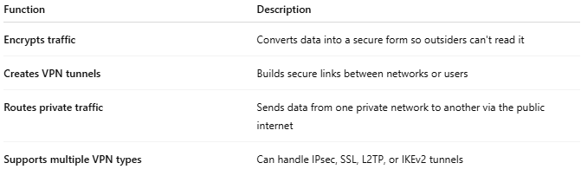

Function | Description
Encrypts traffic | Converts data into a secure form so outsiders can't read it
Creates VPN tunnels | Builds secure links between networks or users
Routes private traffic | Sends data from one private network to another via the public internet
Supports multiple VPN types | Can handle IPsec, SSL, L2TP, or IKEv2 tunnels

🧱 Example Use Cases
# Source: AI Source: Provided by: [Data Path: Persons Table -> ID Column: 1, Name_En Column: Motasem Essam] -> From: [ChatGPT] on [12/18/2025]
- Remote User Access:

[Remote Laptop] ⇄🌐 [VPN Gateway] ⇄ [Corporate Network]

- Site-to-Site VPN:
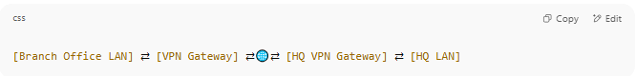
[Branch Office LAN] ⇄ [VPN Gateway] ⇄🌐⇄ [HQ VPN Gateway] ⇄ [HQ LAN]

- Cloud VPN:

[On-Prem Network] ⇄ [VPN Gateway] ⇄🌐⇄ [AWS/Azure VPN Gateway] ⇄ [Cloud VPC]

🧠 Types of VPN Gateways
# Source: AI Source: Provided by: [Data Path: Persons Table -> ID Column: 1, Name_En Column: Motasem Essam] -> From: [ChatGPT] on [12/18/2025]
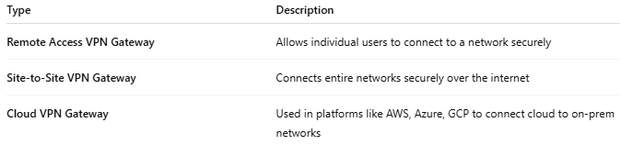

Type | Description
Remote Access VPN Gateway | Allows individual users to connect to a network securely
Site-to-Site VPN Gateway | Connects entire networks securely over the internet
Cloud VPN Gateway | Used in platforms like AWS, Azure, GCP to connect cloud to on-prem networks

🔐 Common VPN Protocols Supported
# Source: AI Source: Provided by: [Data Path: Persons Table -> ID Column: 1, Name_En Column: Motasem Essam] -> From: [ChatGPT] on [12/18/2025]
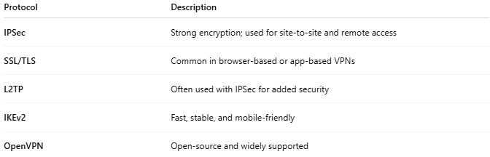

Protocol | Description
IPSec | Strong encryption; used for site-to-site and remote access
SSL/TLS | Common in browser-based or app-based VPNs
L2TP | Often used with IPSec for added security
IKEv2 | Fast, stable, and mobile-friendly
OpenVPN | Open-source and widely supported

✅ Advantages
# Source: AI Source: Provided by: [Data Path: Persons Table -> ID Column: 1, Name_En Column: Motasem Essam] -> From: [ChatGPT] on [12/18/2025]
- ✅ Secures data over untrusted networks (like the internet)
- ✅ Enables remote work and multi-site connectivity
- ✅ Works across on-premises and cloud environments
- ✅ Supports encryption, authentication, and access control

❌ Disadvantages
# Source: AI Source: Provided by: [Data Path: Persons Table -> ID Column: 1, Name_En Column: Motasem Essam] -> From: [ChatGPT] on [12/18/2025]
- ❌ Requires configuration and maintenance
- ❌ May reduce speed due to encryption overhead
- ❌ Needs security policies to avoid misuse
- ❌ Cloud VPN Gateways may cost extra and have bandwidth limits

🏷️ Popular VPN Gateway Devices & Services
# Source: AI Source: Provided by: [Data Path: Persons Table -> ID Column: 1, Name_En Column: Motasem Essam] -> From: [ChatGPT] on [12/18/2025]
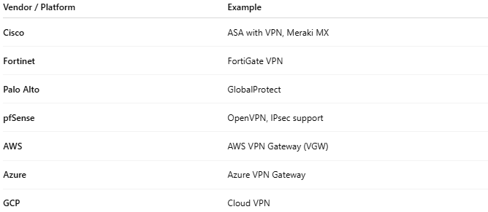

Vendor / Platform | Example
Cisco | ASA with VPN, Meraki MX
Fortinet | FortiGate VPN
Palo Alto | GlobalProtect
pfSense | OpenVPN, IPsec support
AWS | AWS VPN Gateway (VGW)
Azure | Azure VPN Gateway
GCP | Cloud VPN

📌 Summary
# Source: AI Source: Provided by: [Data Path: Persons Table -> ID Column: 1, Name_En Column: Motasem Essam] -> From: [ChatGPT] on [12/18/2025]
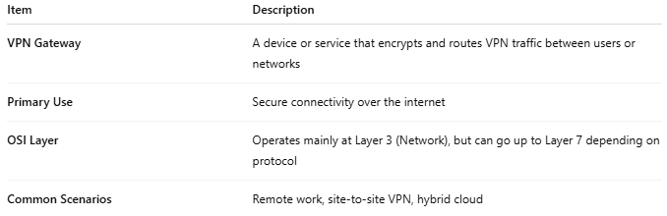

Item | Description
VPN Gateway | A device or service that encrypts and routes VPN traffic between users or networks
Primary Use | Secure connectivity over the internet
OSI Layer | Operates mainly at Layer 3 (Network), but can go up to Layer 7 depending on protocol
Common Scenarios | Remote work, site-to-site VPN, hybrid cloud

